|  |
| --- |
|  |
| CSS And CSS3 Assignment |
|  |

|  |
| --- |
| Admin  [Pick the date] |

1. What are the benefits of using CSS?
   * + - Using CSS we style and format a web page.
       - CSS works according device size.
2. What are the disadvantages of CSS?

* Different browser works differently.
* It’s confusing due to many levels of CSS.

1. What is the difference between CSS2 and CSS3?

* CSS not support responsive designing.
* CSS3 support responsive designing.

1. Name a few CSS style components.

* There are three CSS style components.

1. Selector
2. Property
3. Value

Example:

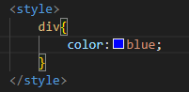

1. What do you understand by CSS opacity?

* Opacity is use to set the opacity (Transparency) of an element.
* The value of opacity is 0 to 1.

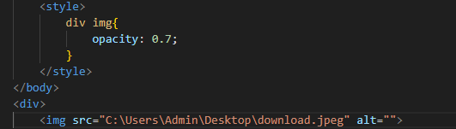

1. How can the background color of an element be changed?

* Background color property is use to set the background color on an element.

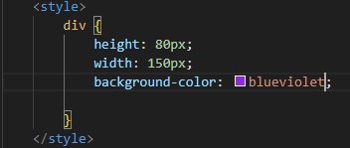

1. How can image repetition of the backup be controlled?

* Background-repeat property is use to control the image repetition of the backup.
* No-repeat value used with background-repeat property.

Example:

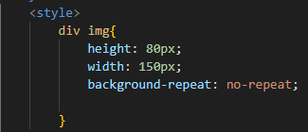

1. What is the use of the background-position property?
   * The background-position property is use to set the position of background image.

Example:

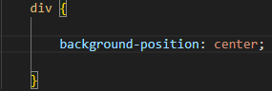

1. Which property controls the image scroll in the background?

* Background-attachment property is use to control the image scroll in the background.

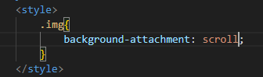

1. Why should background and color be used as separate properties?

* Background-color property is use to set the background color.
* Color property is use to set color of text.
* We use background and color properties as a separate because if we not use background and color property as separate then it will be conflict.

1. How to center block elements using CSS1?

* Using center property we can set block elements at the center.

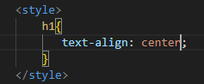

1. How to maintain the CSS specifications?
   * The CSS specifications are maintained by World Wide Web Consortium(W3C).
2. What are the ways to integrate CSS as a web page?
   * There are three ways to integrate CSS as a web page.

**Inline CSS**:

Screenshot 2024-01-18 212204.png

**Internal CSS**:

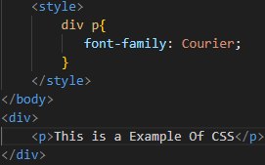

**External CSS:**

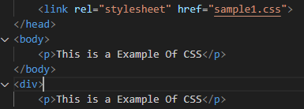

1. What is embedded style sheets?

* Embedded style sheet is used to set style for HTML document in one place using <style>tag.

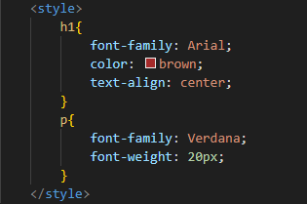

1. What are the external style sheets?
   * To apply CSS in multiple pages external style sheet is used.
   * We create a link in head section in html file to access the external CSS.

**Example**:

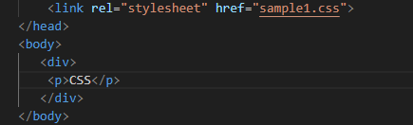

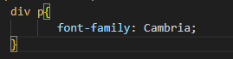

1. What are the advantages and disadvantages of using external style sheets?

* Advantage:
  + We can style to multiple web pages in on CSS file.
* disadvantage:
  + Slower page load time.

1. What is the meaning of the CSS selector?

* Selectors are used to select HTML element you want to style.
* In the below example p is a selector.

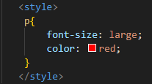

1. What are the media types allowed by CSS?

* 320px — 480px:- Mobile devices
* 481px — 768px:- iPads, Tablets
* 769px — 1024px:- Small screens, laptops
* 1025px — 1200px:- Desktops, large screens
* 1201px and more :-   Extra-largescreens, TV

1. What is the rule set?

* A CSS rule set contains one or more selector and one or more declaration.